REQUESTING A CD IN MEDINFORMATIX
IMPORTANT! MAKE SURE YOU HAVE THE TYPE OF EXAM(S) AND THE DATE(S) OF THE EXAM(S) BEFORE STARTING THIS PROCESS!
- Select “Request Burn CD” on Tree
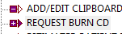
- Select “To Be Picked Up” or “To Be Mailed” or “Email”
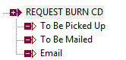
- Select OK
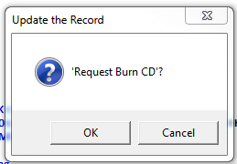
- Select New Note
- Enter note indicating what the patient wants. i.e. Patient will p/u OR send CD to patient
- Select Save
- Select Exit – Authorization to Release Health Care Information will pop up
- Make certain ALL information is correct and filled out
  - Confirm phone number
  - Purpose: Click box next to reason
  - Method: Click box indicating method of delivery
  - Click box next to “Exam Requested”
  - Confirm that exam listed is the correct one
  - Additional Notes: IF ADDITIONAL IMAGES ARE NEEDED ON CD
    - Include date as well as exam description
  - Click box(s) next to what is being requested: Report/Image/Report & Image
  - Select Save

