To use Evicore

https://www.medsolutionsonline.com/portal/server.pt/community/msi_customers/204

Login: vvaladez@valleyrad.com
Password: glamis

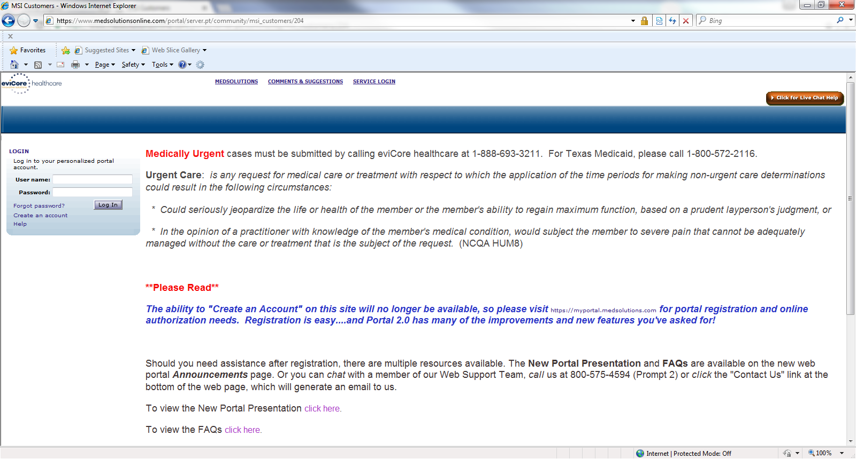
Select Login

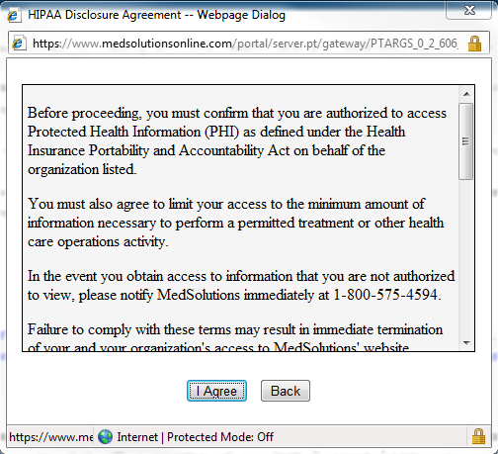
Select I Agree

First step is to select correct insurance company from the drop down on the left
Then enter the member ID
Select Search

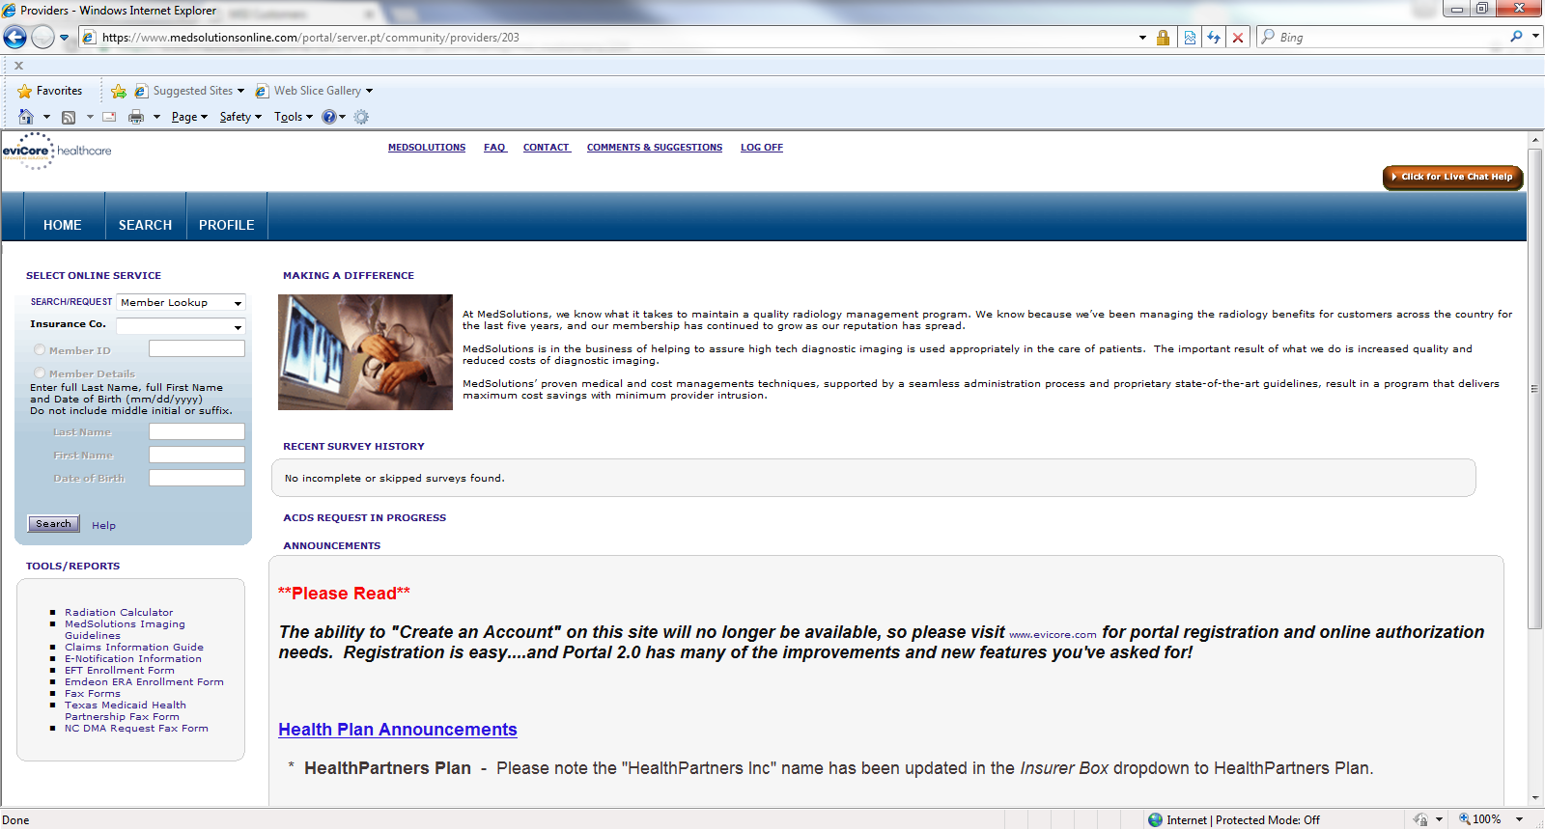

Select the correct patient if you notice more than one member listed
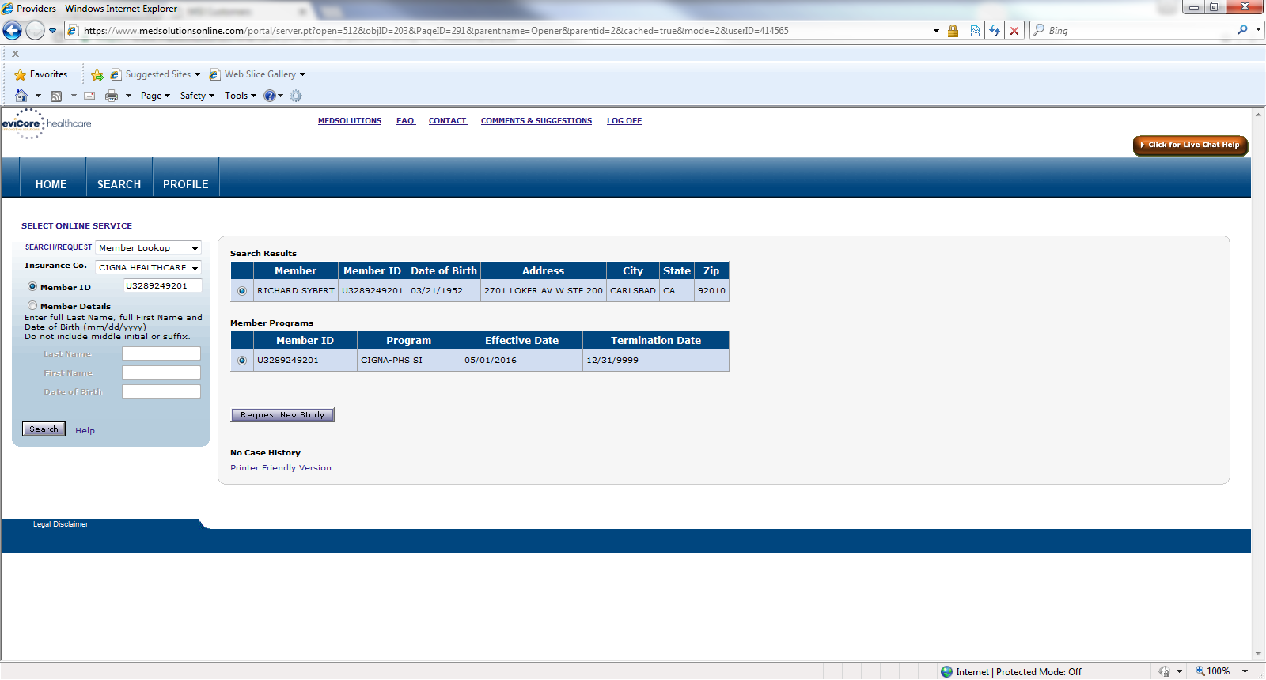
Select Request New Study

Enter the referring provider in the fields listed below
You will enter First, Last, and the State fields
Press Search
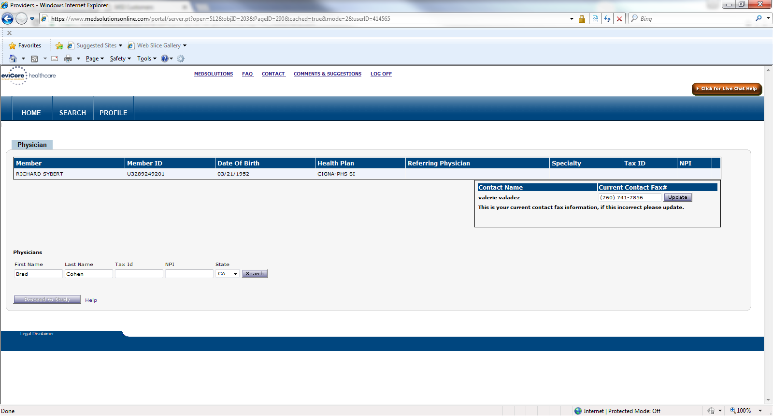
Select the Correct providers correct address

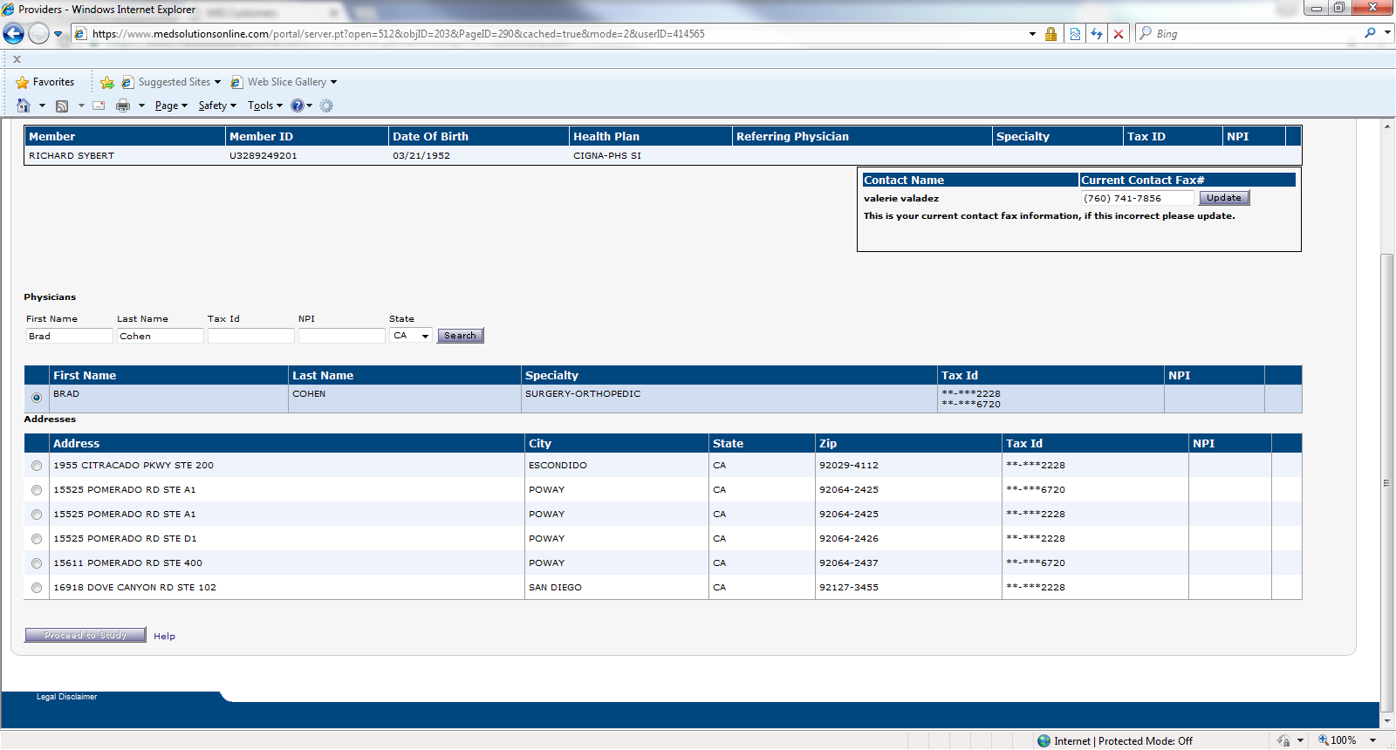

Add the patients phone number
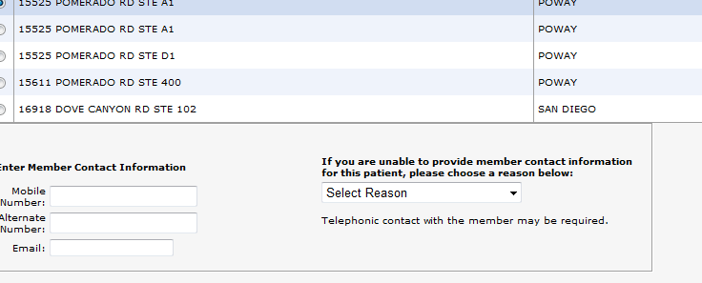
Select Proceed to Study

Select HI-TECH for the next option
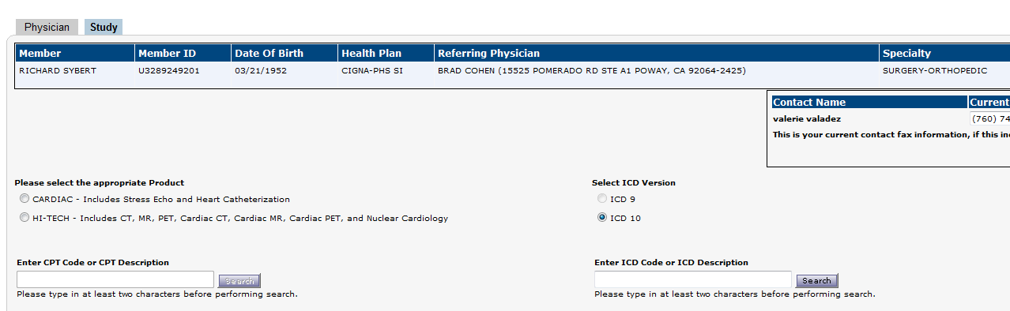
If the noted message in blue appears, you must call the health plan to inquire if AUTH is or is NOT required through health plan. If this message appears, you are done with this screen and cannot move past.

If the Pre-Certification message does not appear, then you will add the CPT Code if you know it. If you do not know it, then enter the type of exam (MRI), and the body part, then select Search. You will notice a screen that has the MRI Thoracic Spine. Select the box, and click on ADD CPT’s. Then enter the CPT code into the search field.
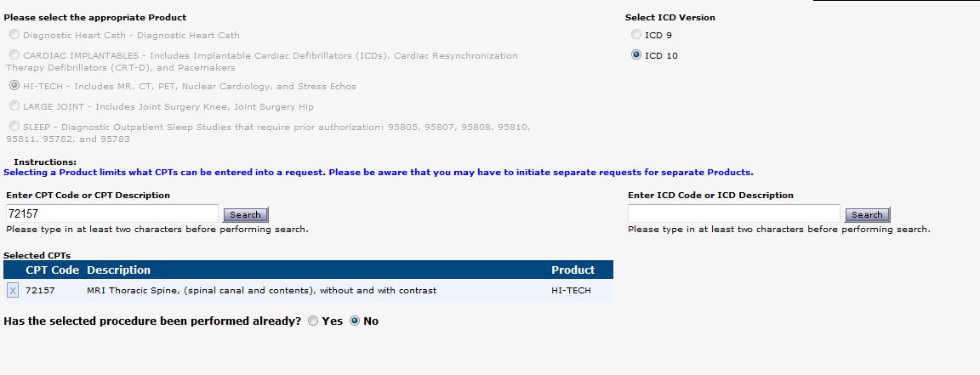

Then add the ICD Code or ICD Description. This is the diagnosis code that the provider put on the order.
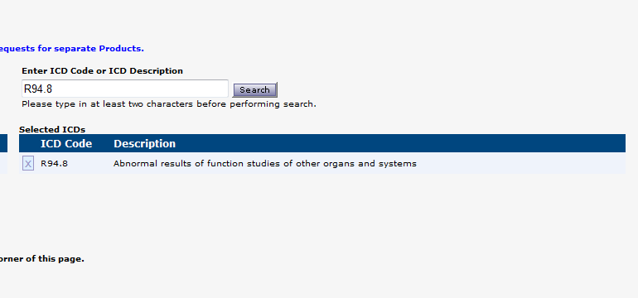

Then select CONTINUE at the bottom of the page
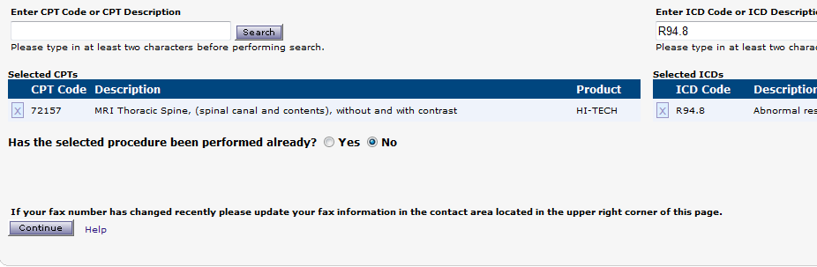

This screen is where you will select the facility for the exam to be done. If you do not see Gateway, Parkway on Elm, then search at the bottom. YOU MUST USE THE NPI# ONLY

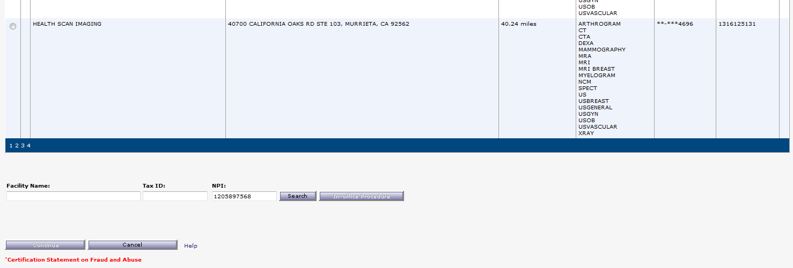

Normal procedure is to just select Parkway on Elm (Patient can go to any of these 3 sites)

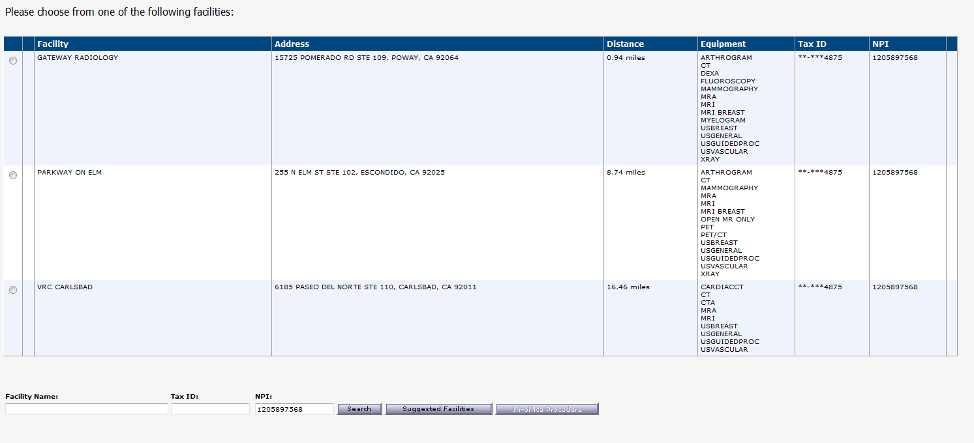
After you select Parkway on Elm, the next screen will look close to the screen you were just on. Just look at the bottom. You have to select a reason. Select Continuity of Care, and type a note of Closer
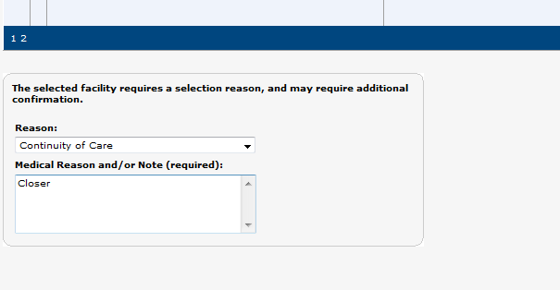

You will need to select an option from the drop down. Refer to case/chart notes for guidance. If you are unable to locate an actual reason, select NOT LISTED, then type a reason. Then press Continue
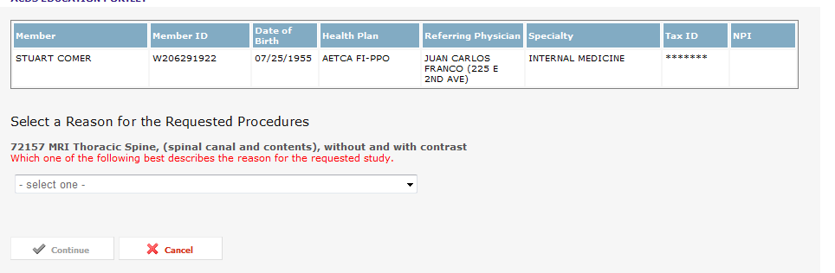

Press Continue
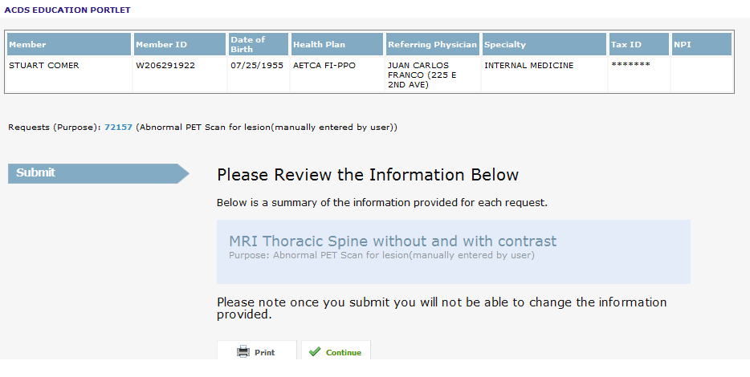

You may encounter a screen that will prompt for action. Select Submit for Additional Review, then press Submit All.

This next screen will ask you to scan the documents and attach them for review. Select Attach / Add addition clinical information below

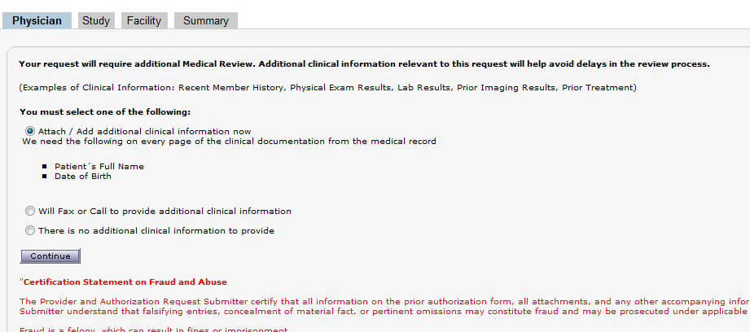

When you select continue, you will be prompted to attach the documents. Scan the documents, then Browse to the location that the scanner holds the documents. For Valley, it will be C:\RLOGIC/SCAN

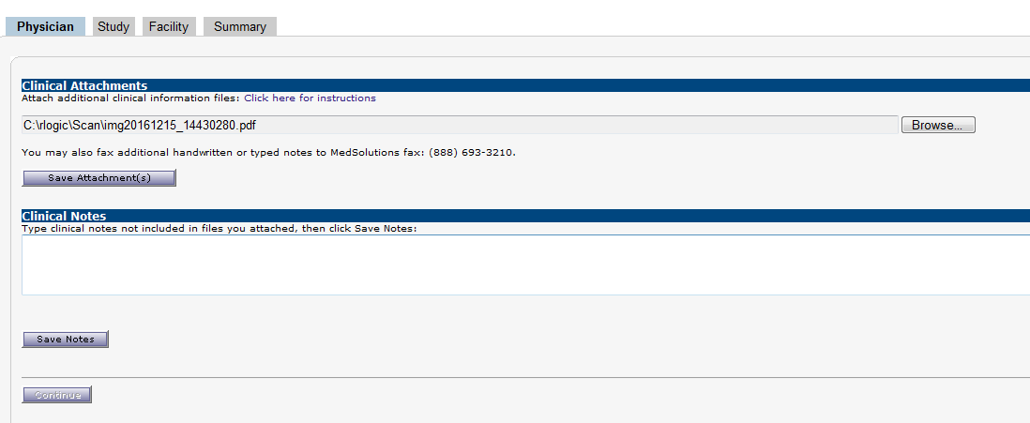

Select Save Attachment(s)
Press continue

The next screen will be the confirmation and will also provide a case number.
You will need to put a note in the appointment note, provide the case number listed, and the date submitted.

