MEDICAL RECORDS PROCESSING
These are the steps for the Medical Record Person for each of the nodes in the workflow.
PHONES: Any time the phone rings, and the person is looking for a specific exam.
Step 1: Go to the Patient list
Step 2: Find the Patient. Use either the Name, Account, DOB, Phone or ApptNo fields.
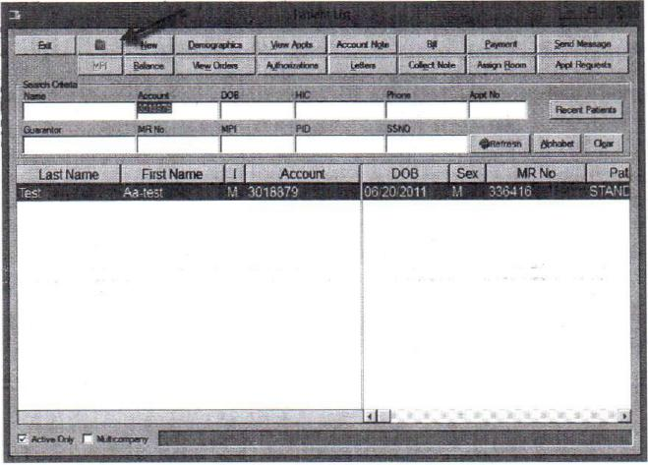
Step 3: If the patient is requesting a CD:
- Click Request Burn CD
- Select either 'To Be Picked Up', 'To be Mailed', 'Email' as the appropriate response of how the patient will get their CD.
Step 4: Fill out the Medical Records Release form.
- Fill out the exam and any check boxes that are applicable.
- Save the document.
Step 5: Print the patients report.
- Go into the Repository.
- Find the Report for the exam in question.
- Print the report or Fax the report.
Step 6: If you have any documents that need to be scanned in, go to the Scanned documents branch.
- Put the piece of paper in the scanner.
- Select the name of the document

- Paper will scan in and automatically save to the Repository under the appointment you are in.

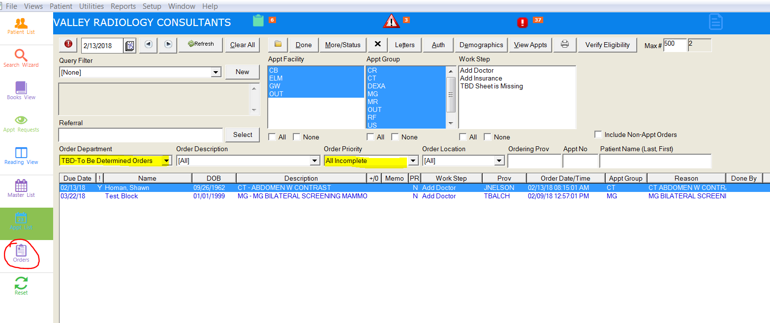
ORDERS: Tasks that need to be completed daily.

TBD
Step 1: Look for the 'To Add Doctor' document in the Repository.
Step 2: Add the new Referring Physician to MI. Documentation on how to do so in another form.
Step 3: Change the Referral Source on the appointment to the new Referral by using the Edit
Appointment Info screen.
Step 4: Mark the task Done.
HOLD
Step 1: Find the HOLD orders that have a workstep of 'On Hold by Rad'.
Step 2: Look in the 'On Hold Radiologist Notes' branch to determine the issue.
Step 3: Correct the issue.
Step 4: Send back to the Radiologist, by clicking the 'Complete Exam' branch. Make sure the workstep
on the clipboard changed from 'On Hold' to `(Routine, Stat, ASAP) Ready to Read'.
Step 5: Mark the task Done.
MEDICAL CD
Step 1: Go into the patient's chart and go into the Repository. Find the Medical Record Release form.
Step 2: Print out the form. Burn the CD based on what it says.
Step 3: Determine how patient is going to receive their CD.
- Patient will pick CD up.
I. Put CD and paperwork in bin.
- Patient wants the CD mailed.
I . Print the reports and print a label.
II. Mail CD and paperwork to the patient.
- Patient wants the CD emailed.
I. Email all paperwork and images through email process.
Step 4: Mark the task Done.

OUTSIDE PRIORS: Worked to obtain outside priors for appointments.
Step 1: Work the PRIORS list in the Orders View.
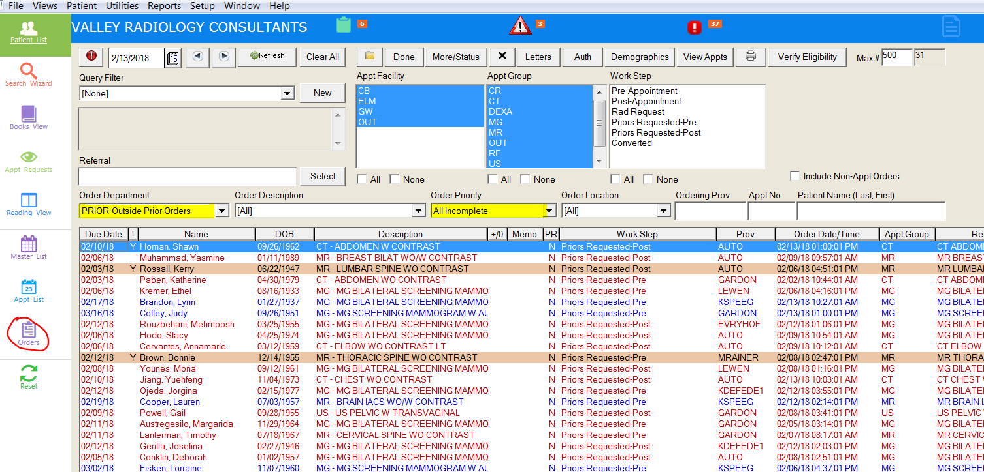

Step 2: Go into the patient's chart. Look on the clipboard to determine where the priors are located.
Step 3: Fill out the Medical Records Request form, and fax it to the appropriate location.
Step 4: Save the form, or scan the form into the repository if it was printed out.
Step 5: Put notes in the Medical Record Notes branch that the priors have been requested.
Step 6: When the prior images have arrived, import the images into PACS. Make a note in the patient's chart using the 'MEDICAL RECORDS NOTES' branch that the images are now here.
Step 7: Mark the task Done.
Worksteps:
Pre-Appointment- gets created when the schedulers say the patient has relevant Outside Priors.
Post-Appointment- gets created when the technologists complete the exam and say the exam is missing priors.
Rad Request- gets created when the radiologist notates that priors are missing.
LIENS: Whenever a Lien patient is being seen.
Step 1: Go into the Appointment Request View.
Step 2: Add Request

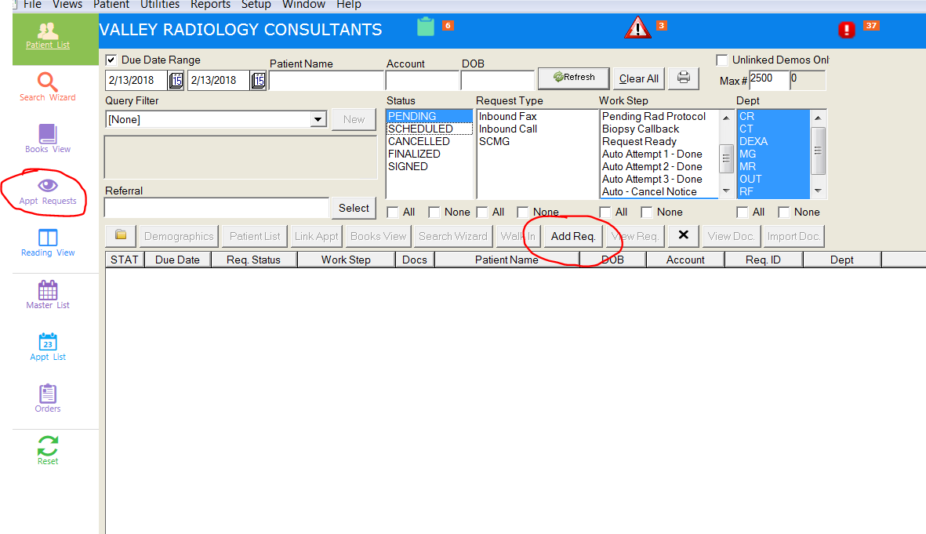
- Fill in the patient's name.
- Fill in the referring physician.
- The Workstep should be 'Pending Lien'.
- Fill in the type of appointment.
- Change the Coverage Type to 'L- Lien'.
- Scan in the document to the request.
- Put in any notes in the Request Notes field.
- Attorney Information
- When the Lien was sent to the Attorney.
- When the signed Lien was received, etc.

Step 3: Once all information is present for the Lien, move the workstep to 'Docked'. This means the patient will get a tail to schedule the exam.
CLINICAL TRIALS: Any time a clinical trial patient needs to be scheduled.
Step 1: Go to the Books View.
Step 2: Select the Facility that the patient will be seen.
Step 3: Pick the modality for the exam.
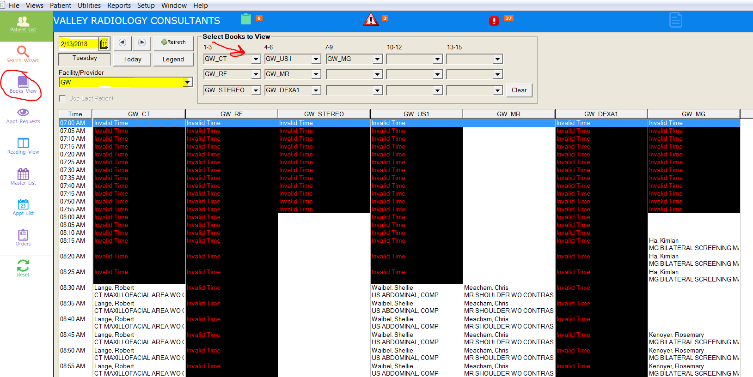

Step 4: Select the date. Double click, or right click-Set Appointment, on the time slot that the patient can come in. Make sure that the cursor is under the correct Book.
Step 5: Select the correct exam description.
Step 6: Search for the patient (clinical trial) that you are scheduling. Enter in all the needed information.
More details on scheduling is in the 'Scheduling in Ml' documentation.

TELERADIOLOGY: Any time an outside read patient needs to be scheduled.
Step 1: Go to the Books View.
Step 2: Select the facility 'OUT', and select the Book that correspond to the Teleradiology company.

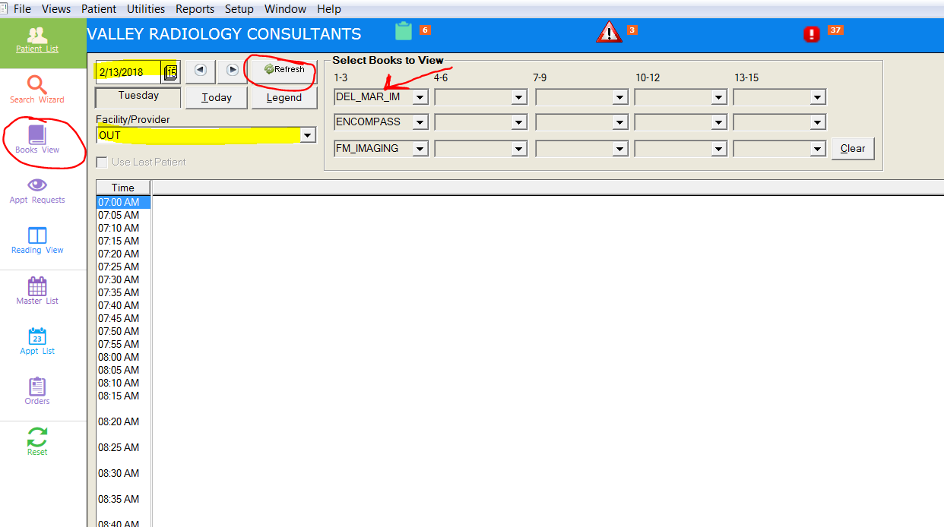

Step 3: Make sure the date is the day the exam was originally completed. Double click, or right click-Set Appointment, on the time slot that the patient can come in. Make sure that the cursor is under the correct Book.
Step 4: Select the correct exam description.
Step 5: Search for the patient that you are scheduling.
Step 6: When the Confirm Appointment screen appears, change the Coverage Type dropdown to `G —Group'.
Step 7: Enter the Referring Physician's name. Press OK
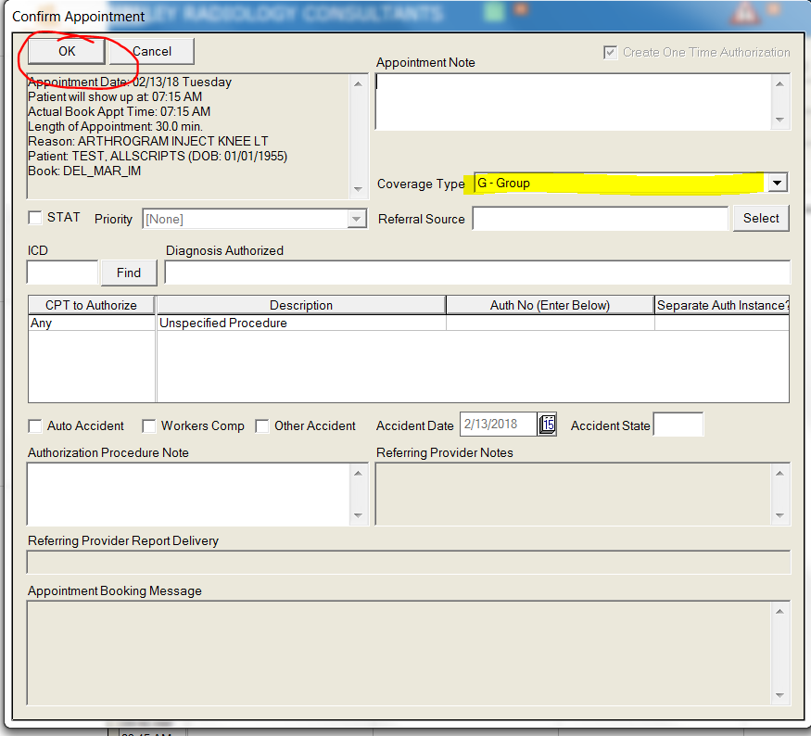

Step 8: Go into the Demographics branch.
- Enter the Group into the insurance section. (i.e. if the group is Indian Health Council⁻ add
Indian Health Council as the insurance coverage).
- Enter '111' as the policy number.
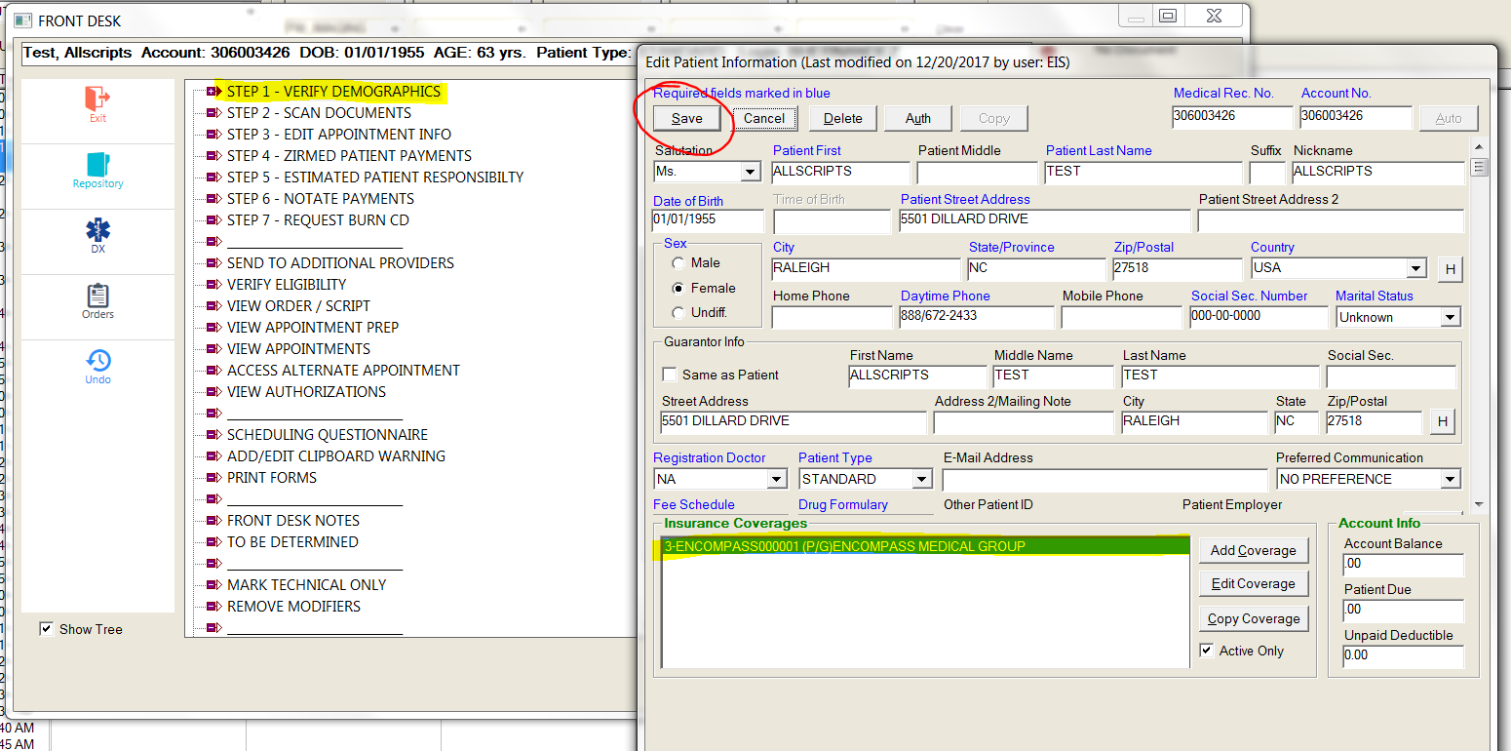

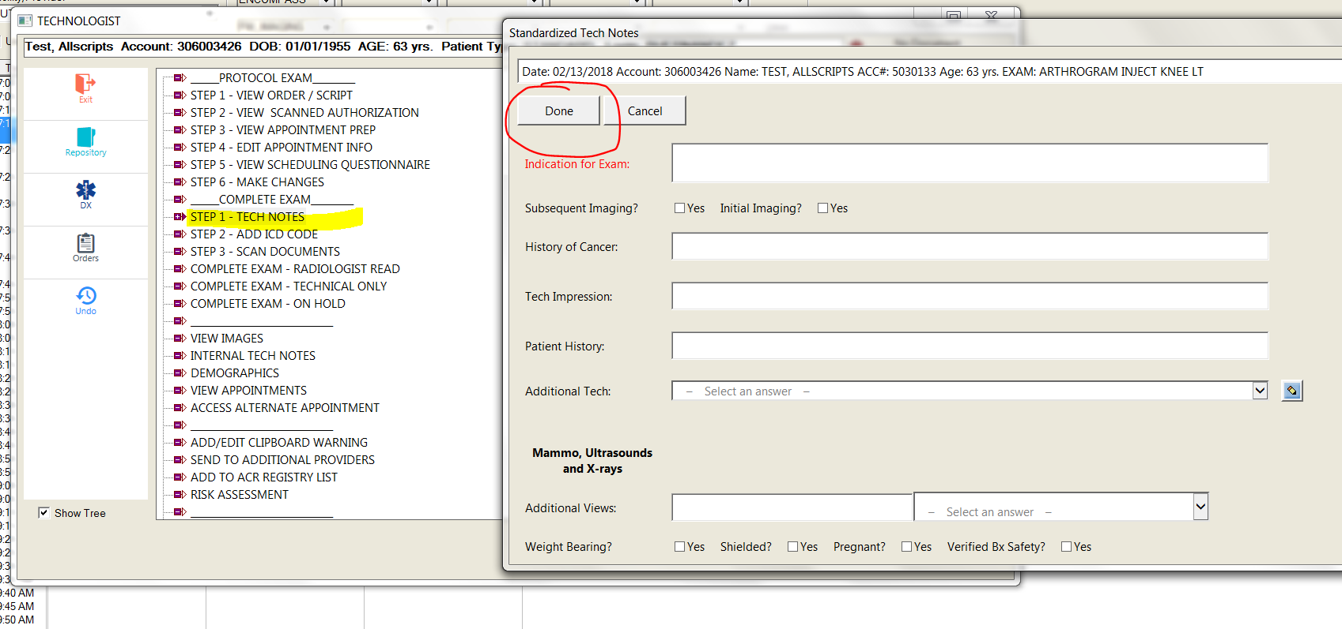
Step 9: Go into the Tech Notes branch. Enter in any indications and views from the paperwork.

Step 10: Attach the images in PACS to the Medlnformatix appointment number.
Step 11: Import the order into the appointment.

